**Ranjan Jana**

Salt lake sector V, Kolkata-700102 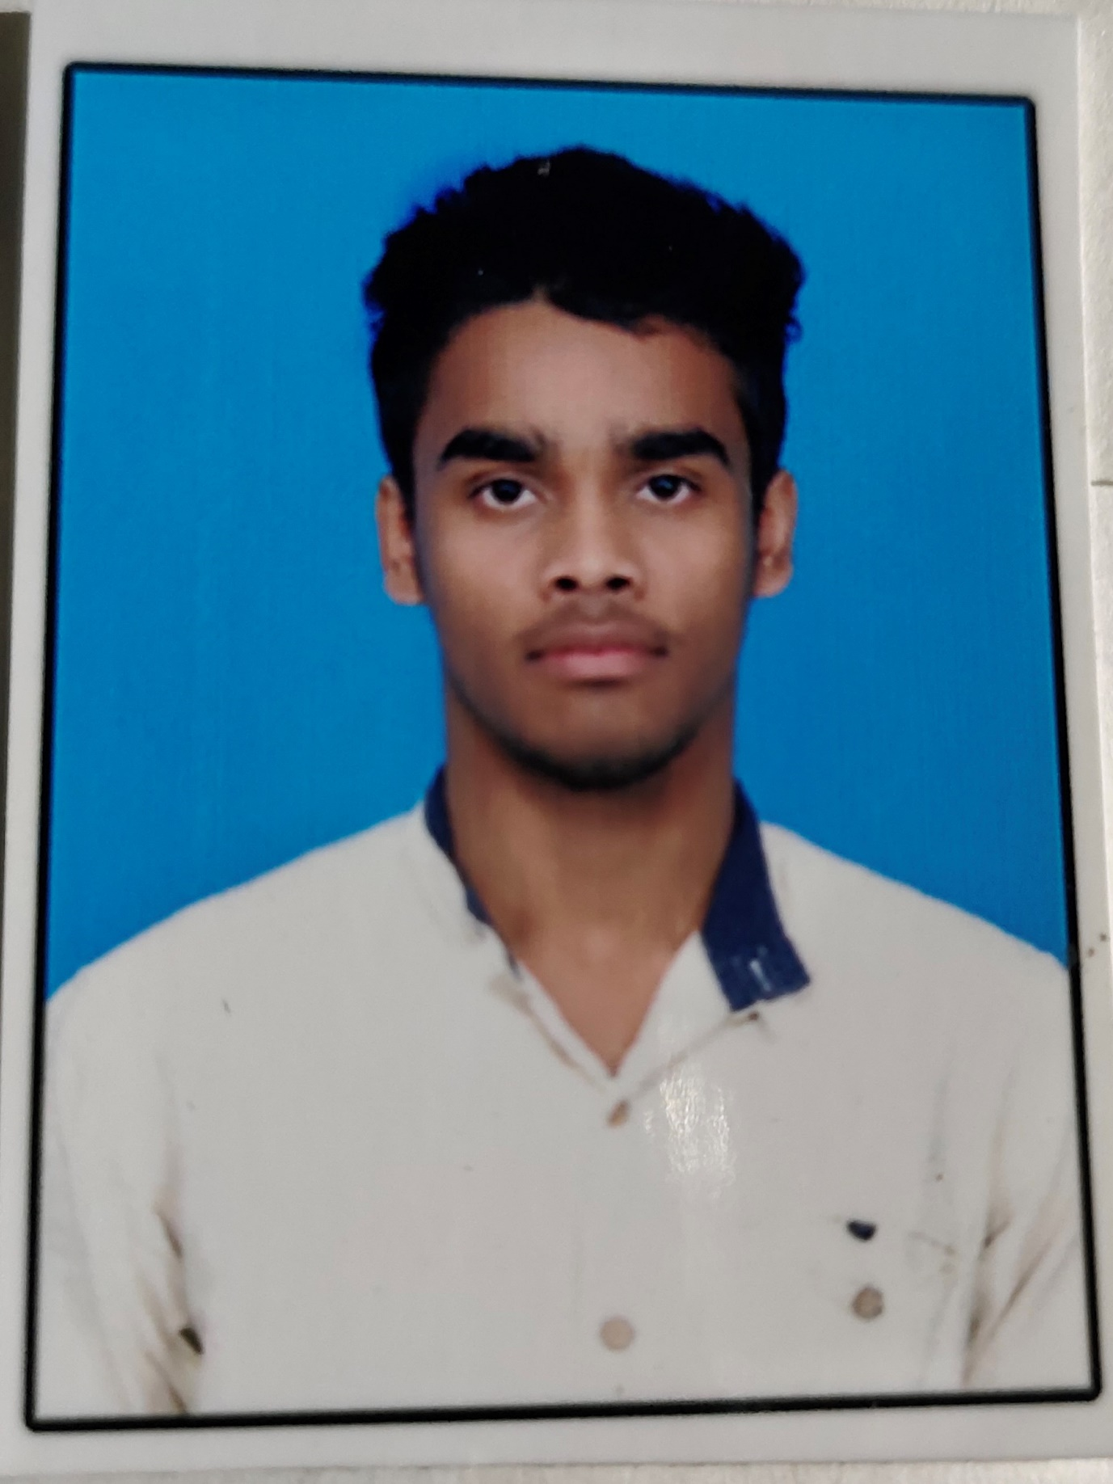

Email : [ranjanjana5398@gmail.com](mailto:ranjanjana5398@gmail.com)

Mobile No.: 6295200371

Alternate Mob.: 9538043475

**SUMMARY**

To be associated with a progressive organization which can provide me a dynamic work sphere to extract my inherent skill as a professional, use and develop my attitude and knowledge to further the organization's objective and progress.

**MAJOR PROJECTS AND SEMINARS**

**Automatic street light system using LDR**

(1 Jan'15 - 15 Jan'15)

It's a LDR base project

**Study the size of window for sliding window protocol of data link layer**

(23 Jun'18 - 29 Jun'18)

This project is a thesis base project how to minimize the time, bandwidth propagation delay, number of bits for sender window and extension of the protocols.

**Bluetooth control car**

(12 Jul'16 - 20 Jul'16)

This controlled by our mobile or any Bluetooth device to control the car motion.

**Transmitting the audio signal through the laser**

(23 Jan'16 - 5 Feb'16)

This is laser base communication system it's done by using photodetector.

**Infrared people counter**

(10 Jul'15 - 30 Jul'15)

It's sensor base project which counts the people's passing through the sensor.

**Home security system using GSM module**

(23 Nov'17 - 15 Dec'17)

This is Arduino, GSM module base and sensor base project.

**CERTIFICATES**

**Introduction in SAP ERP using project. Global Bike In. 2.40**

**Training on Microcontroller Based IOT(Arduino & Raspberry Pi)**

Score - 93/100

Have made a successful project on GSM module base.

**SKILLS**

**Databases** – SQL.

**Languages -** C, Java, Python, HTML, CSS, Java Script.

**Electronic Subject-** Analog and Digital electronics, signal and control system,

Communication system.

**ACADEMIC DETAILS**

**Course Institute University/Board Year %/CGPA**

B.tech(ECE) Tecno India University Autonomous 2018 8.75

XII Barhat Sambhu Nath Banipith State board 2014 80

X Katranka Birendra Vidya Mandir State board 2012 83.31

**PERSONAL DETAILS**

**Father Name:** Lakshmikanta Jana.

**Date Of Birth:** 1st march 1997.

**Language Known:** Bengali, English, Hindi.

**Permanent Address**: Villl: Dulalpur, P.O: Katranka, P.S Patashpur,

Purba Medinipur, 721454,West Bengal.

**Current Address:** salt lake sector V, mohisbathan, MB -404, Kolkata 700102

**Hobby:** Reading book and travelling.

**DECLARATION**

*The information which given above, all are from best of my knowledge and truthful.*

**Date: Signature**

**Place:**